
PATUAKHALI SCIENCE AND TECHNOLOGY UNIVERSITY

COURSE CODE CCE 314
Computer Networks Sessional

SUBMITTED TO:

Prof. Dr. Md Samsuzzaman

Department of Computer and Communication Engineering
Faculty of Computer Science and Engineering

SUBMITTED BY:
Md. Sharafat Karim
ID: 2102024,
Registration No: 10151
Faculty of Computer Science and Engineering

Lab 01
Assignment title: Networking devices and their features
Date of submission: 30 Wed, 2025
LAN Devices
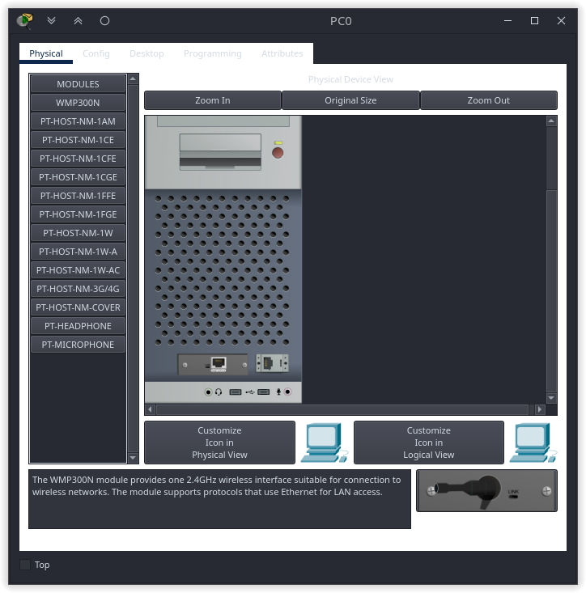
- NIC (Network Interface Card): Also called Network Adapter. It connects a host to a network medium. It provides the physical interface between computer and cabling. It prepares data, sends data, and controls the flow of data. It can also receive and translate data into bytes for the CPU to understand. Contain unique MAC Address to control data communication.
- Repeater: Functioning at Physical Layer. A repeater is an electronic device that receives a signal and retransmits it at a higher level and/or higher power, or on to the other side of an obstruction, so that the signal can cover longer distances. Repeater have two ports, so cannot be use to connect for more than two devices.

- Hub: An Ethernet hub, active hub, network hub, repeater hub, hub or concentrator is a device for connecting multiple twisted pair or fiber optic Ethernet devices together and making them act as a single network segment. Hubs work at the physical layer (layer 1) of the OSI model. The device is a form of multi port repeater. Repeater hubs also participate in collision detection, forwarding a jam signal to all ports if it detects a collision.
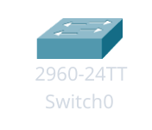
- Switch: A network switch or switching hub is a computer networking device that connects network segments. The term commonly refers to a network bridge that processes and routes data at the Data link layer (layer 2) of the OSI model. Switches that additionally process data at the network layer (layer 3 and above) are often referred to as Layer 3 switches or multilayer switches.

- Bridge: A network bridge connects multiple network segments at the data link layer (Layer 2) of the OSI model. In Ethernet networks, the term bridge formally means a device that behaves according to the IEEE802.1 standard. A bridge and switch are very much alike; a switch being a bridge with numerous ports. Bridges can analyze incoming data packets to determine if the bridge is able to send the given packet to another segment of the network.
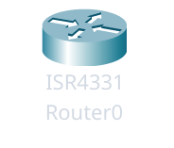
- Router: A router is an electronic device that interconnects two or more computer networks, and selectively interchanges packets of data between them. Each data packet contains address information that a router can use to determine if the source and destination are on the same network, or if the data packet must be transferred from one network to another. Where multiple routers are used in a large collection of interconnected networks, the routers exchange information about target system addresses, so that each router can build up a table showing the preferred paths between any two systems on the interconnected networks.
- Gate Way: A gateway is a hardware device that acts as a "gate" between two networks. A gate way may contain devices such as protocol translators, impedance matching devices, rate converters, fault isolators, or signal translators as necessary to provide system interoperability.

Wires

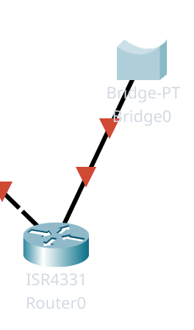
- Copper straight cable: A copper straight cable is a type of network cable that uses copper wires to transmit data. It is commonly used in Ethernet networks and is designed to connect devices such as computers, switches, and routers. The cable consists of four twisted pairs of copper wires, which helps to reduce electromagnetic interference and crosstalk. The straight cable is typically used for connecting devices to a network switch or hub, allowing for communication between devices on the same network segment.
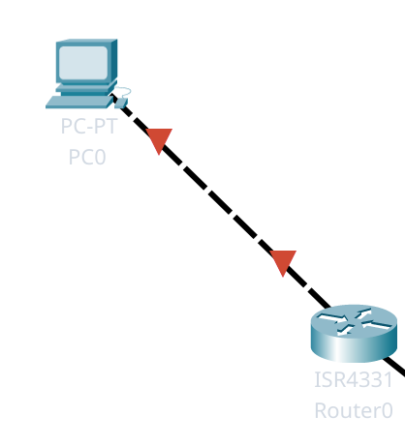
- Copper cross cable: A copper cross cable, also known as a crossover cable, is a type of network cable that is used to connect two devices directly without the need for a switch or hub. It is designed to connect devices such as computers, routers, or switches directly to each other. The cable consists of four twisted pairs of copper wires, but the wiring configuration is different from that of a straight cable. In a crossover cable, the transmit and receive pairs are crossedover, allowing for direct communication between the two devices. This type of cable is often used for connecting two computers directly or for connecting two switches together.
- Fiber optic cable: A fiber optic cable is a type of network cable that uses thin strands ofglass or plastic fibers to transmit data as pulses of light. It is designed for high-speed data transmission over long distances and is commonly used in telecommunications and data networks. The cable consists of a core, which carries the light signals, surrounded by a cladding that reflectsthe light back into the core, and an outer protective layer.
- Coaxial cable: A coaxial cable is a type of electrical cable that consists of a central conductor, an insulating layer, a metallic shield, and an outer insulating layer. It is commonly used for transmitting radio frequency signals, such as those used in cable television and internet connections. The central conductor carries the signal, while the metallic shield helps to reduce electromagnetic interference and crosstalk. Coaxial cables are known for their ability to carry high-frequency signals over long distances with minimal signal loss. They are often used in applications such as cable TV, internet connections, and video surveillance systems.

